The Lady or the Tiger
Frank Stockholm

Once upon a time, there lived a semi-barbaric king who had an unusual way of judging people. When a subject was accused of a serious crime, the fate of the accused person would be decided at a public gathering.
On the trial day, the people would gather in the king’s arena. The king sat high on his throne to one side. A door in the arena would open, and the accused subject would step out into the arena. Across from the accused were two doors. They were exactly the same. The accused must walk to one of these doors and open it. It was his free choice which door to open. But his fate would be decided by which door he chose--only luck could guide him.
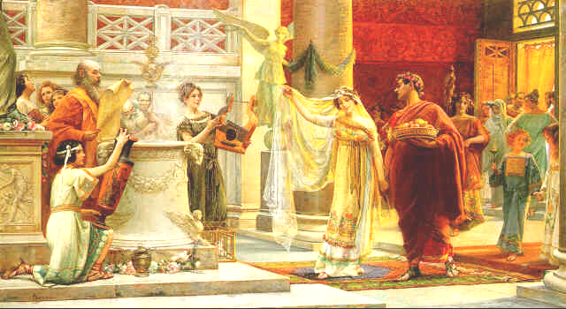
If he opened one door, out would spring a hungry tiger, which would tear him to pieces. This would be taken as proof that the accused was guilty. If he opened the other door, however, a beautiful lady would step out, which proved that the accused was innocent. The two would then be married in a ceremony right there in the arena.
The people liked this kind of trial. When they gathered in the amphitheater on one of the great trial days, they never knew whether they were going to witness a bloody murder or a joyous wedding.

Now, the king had a beautiful daughter. His daughter was madly in love with a young man. But because the young man was of low social position, he and the princess had to keep their love secret from the king. But one day the king saw the two embracing in a garden.
Furious, he called his guards and threw the young man into prison.
On the day of the trial, people came from all over the country to witness the trial. The king and his daughter seated themselves on their thrones opposite the twin doors. A door in the amphitheatre slowly opened and the lover of the princess walked into the arena. A gasp of admiration went up from the audience. They had not known that such a grand youth had been living in their midst. What a terrible thing for him to be on trial for his life because he loved the princess.
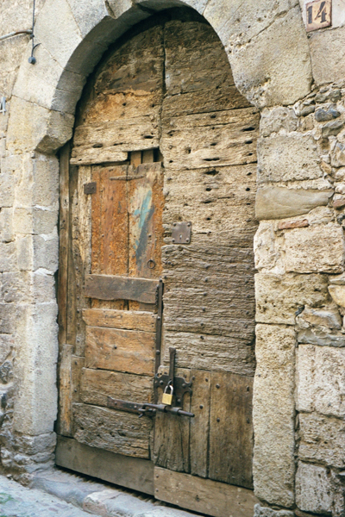
As the young man stepped into the arena, he turned and bowed to the king; however, his eyes were fixed on the princess. This is because he was sure that she knew the secret of what lay behind the two doors. And it is true: she did know behind which door lurked the tiger and behind which stood the beautiful lady. She also knew that the lady was the fairest and the most desirable lady in the entire land. Often the princess had imagined her lover talking to the lady. Their conversation might have been for a moment or two. They might have been talking about an unimportant topic, but how could the princess know that? She was insanely jealous.

Now, as the princess sat on her throne looking down at her lover, she shuddered as she imagined him opening the door to the hungry tiger. But then she imagined him opening the other door. How her soul burned in great pain and emotion as she imagined her lover and the beautiful lady rushing into each other's arms!
Would it not be better to let the tiger devour him, and for him to await her in heaven? But, if he died, the princess knew she would be haunted forever by nightmares of her lover's screams and his pain as he suffered a bloody death.
With anxious eyes, the young man silently begged the princess to save his life. In a flash, the princess made her decision: she glanced quickly to the door on the right. No one but her lover saw her do this.
The young man turned and walked slowly across to the two doors. He went to the door on the right and opened it.
Which came out of the door: the lady, or the tiger?

MATCHING ACTIVITY

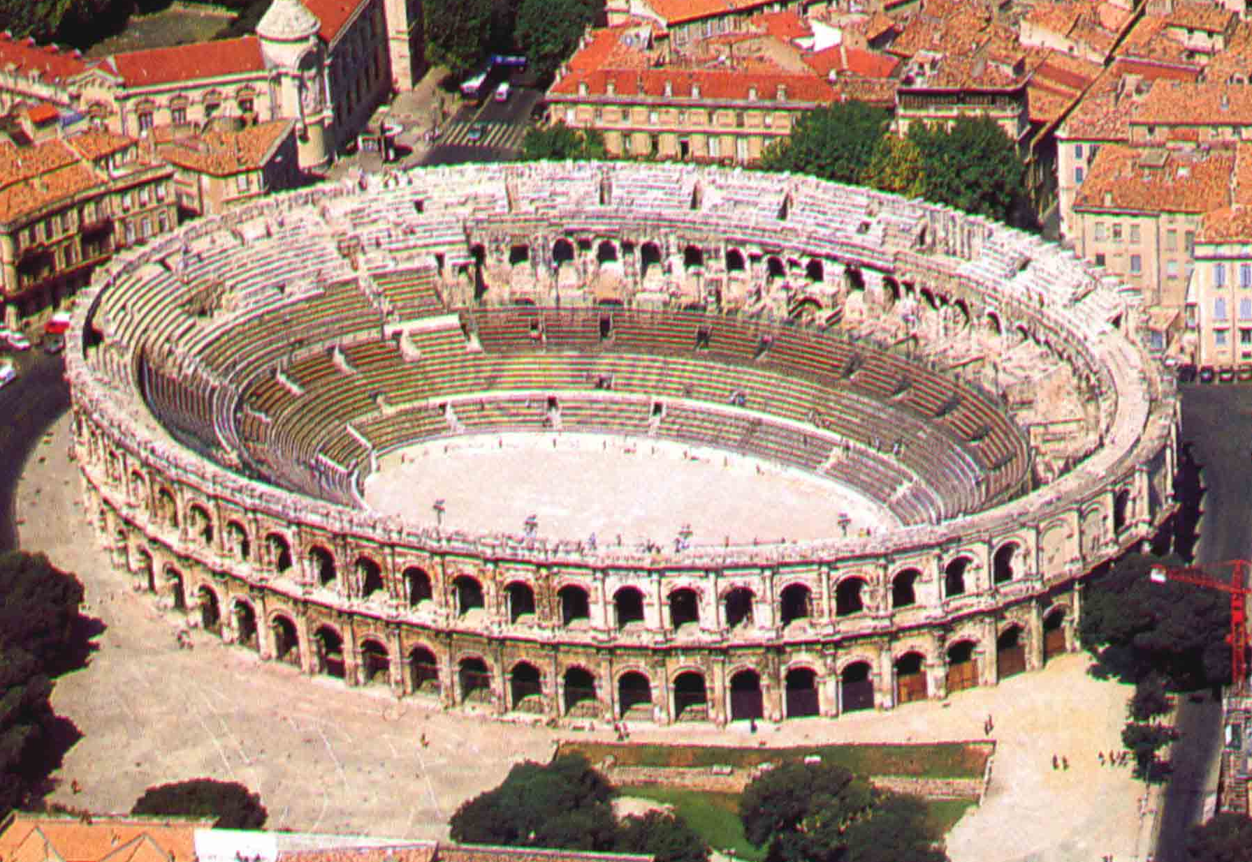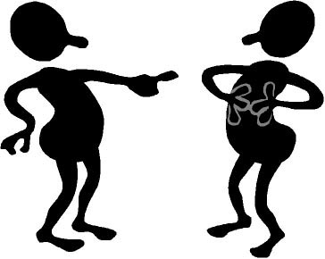

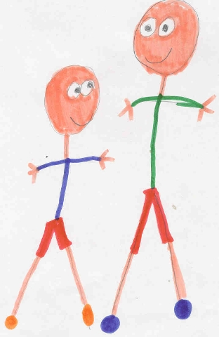



barbarian
shuddering
trial
to devour
lurking
admiration
accusing
amphitheater

Are these statements true or false? Circle your answer.

1. The king told the accused which door to open. T/F

2. Behind one of the doors was a beautiful lady. T/F

3. The princess did not know what was behind the doors at her lover’s trial. T/F

4. The lady behind the door was not very attractive. T/F

5. The princess wouldn’t mind very much if her lover died. T/F

Finish the sentence.

- The princess felt jealous when_________________________________________.
- Because the young man was not royalty, ______________________________________________.
- In order to tell her lover which door to pick, the princess ______________________________________.
- The young man must have trusted the princess because_______________________________________.

Which did the princess choose? Choose a side and list your reasons.

The lady | The tiger

